Eksamen 2015
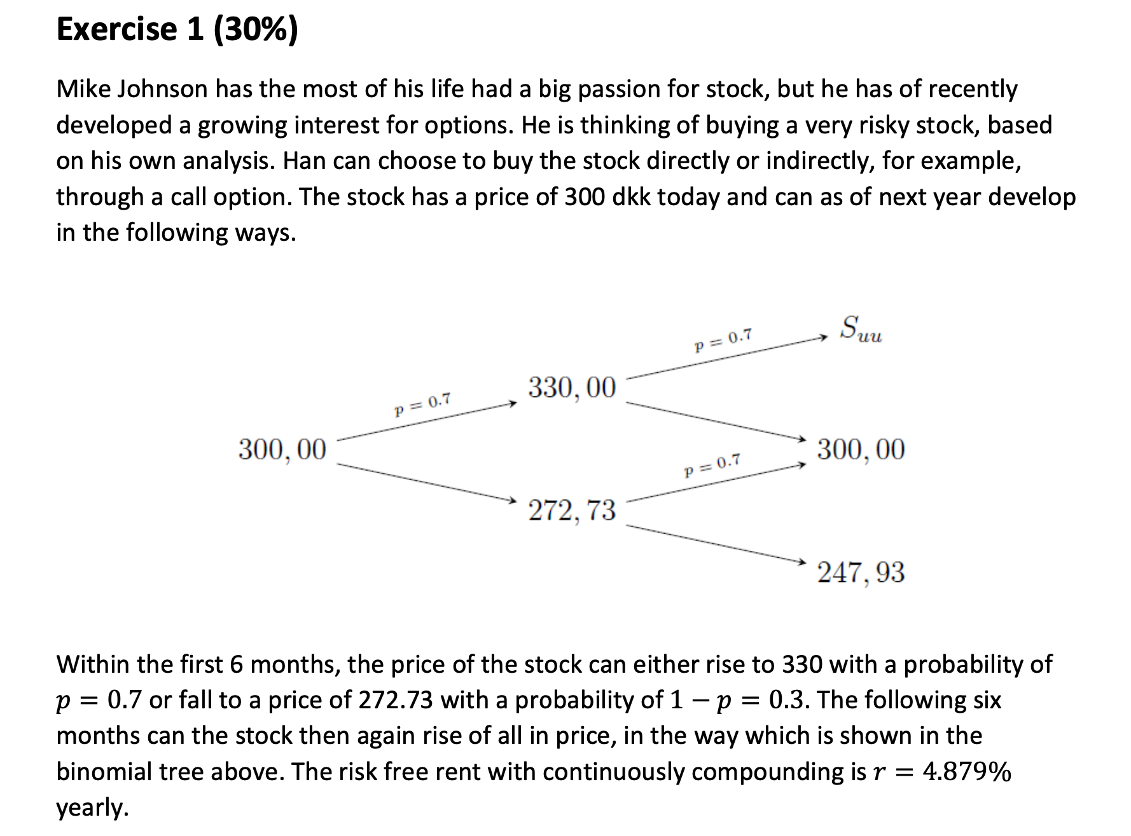
$$1+r=e^{\frac{0.04879}{2}}=1,0247$$
Market is arbitrage free if and only if $u>1+r>d$
$$u>1+r⇔s_{uu}>s_{u}·\left(1+r\right)=330·1,0247=338,15$$
We must have a strictly higher price than the $338.15$ otherwise if we go up in first period we sell short the stock and invest risk free achieving arbitrage

We have constant risk neutral properbilities if we have constant up and downs thus we need $S_{uu}=1.1·s_{u}=363$
The q’s of the latter setting is
$$u=1.1$$
$$d=\frac{1}{1.1}=0,90909$$
$$\frac{e^{\frac{r}{2}}-d}{u-d}=\frac{1,0247-0,90909}{1.1-\frac{1}{1.1}}≈0,60558$$
$$1-q=1-0,60558=0,39442$$
2)
$$P_{E}=e^{-0.04879}\left({\left(1-0,60558\right)}^{2}·\left(295-247.93\right)\right)≈6,9739$$

3)
$$P_{du}=0$$
$$P_{dd}=295-247.93=47,07$$

$$Δ·300+B·e^{\frac{0.04879}{2}}=0$$
$$Δ·247.93+B·e^{\frac{0.04879}{2}}=47,07$$
$⇕$ Ligningssystemet løses for Δ,B vha. WordMat's 'Løs Ligninger' funktion,
$$Δ=-\left(\frac{4707}{5207}\right) ≈-0,90398$$
$$B=\frac{1461308084145}{5521518421}≈264,66$$
4)
$$C-P=S-K·e^{-rT}$$
$$C=6,9739+300-295·e^{-0.04879}≈26,021$$
5)
$$u=e^{σ·\sqrt{Δt} }$$
$$d=e^{-σ\sqrt{Δt}}$$
$$1.1=e^{σ·\frac{1}{\sqrt{2}}}$$
$⇕$ Ligningen løses for σ vha. WordMat.
$$σ=0,13479$$
Bsm call price
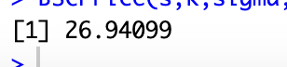
Its rather close to the price found before
The diffrence should come from the difference in framework i.e the price for a binomial jumping more and more often converges towards the BSM approach
The difference is that the binomial model is a completely different model
6)
a)
$$\frac{320-300}{300}≈0,066667$$
b)
$$\frac{25-27,029}{27,029}≈-0,075068$$
Buying the option has lower return
Buying stock ended up better in this senario

Exercise 2

- Write down the stream of payments for each bond
We find the annuity payments im assuming a face value of 100 in each case
B1
$$1.03·100-x=0$$
$⇕$ Ligningen løses for x vha. WordMat.
$$x=103$$
B2
$$\left(\left(100·1.04-x\right)·1.04-x\right)=0$$
$⇕$ Ligningen løses for x vha. WordMat.
$$x=53,02$$
B3
$$\left(\left(\left(100·1.06-x\right)·1.06-x\right)·1.06-x\right)=0$$
$⇕$ Ligningen løses for x vha. WordMat.
$$x=37,411$$
Thus the market can be written as
$$B=\left(\begin{aligned}B_{1} \\ B_{2} \\ B_{3}\end{aligned}\right)=\left(\begin{matrix}103 & 0 & 0 \\ 53.02 & 53.02 & 0 \\ 37.411 & 37.411 & 37.411\end{matrix}\right)$$
The matrix is clearly invertible and thus the market is complete also we see that we can easily create any cashflow by a linear combination of the assets
2) find the discntfactors and decide if the market is arbitrage free
$B invertible ,d=B^{-1}P>0⇒$(B,P) is arbitragefree
$${\left(\begin{matrix}103 & 0 & 0 \\ 53.02 & 53.02 & 0 \\ 37.411 & 37.411 & 37.411\end{matrix}\right)}^{-1}\left(\begin{aligned}98.880 \\ 99.147 \\ 101.758\end{aligned}\right)≈\left(\begin{matrix}0,96 \\ 0,90999 \\ 0,85001\end{matrix}\right)>0$$
Da er markedet specielt arbitragefrit
$$s_{t}=d_{t}^{-1/t}-1$$
$$s_{1}={0,96}^{-1}-1≈0,041667$$
$$s_{2}={0,90999}^{-\frac{1}{2}}-1≈0,048291$$
$$s_{3}={0,85001}^{-\frac{1}{3}}-1≈0,055663$$
We find forward 1,2 first
$$(1+s_{1})\left(1+f_{1,2}\right)={\left(1+s_{2}\right)}^{2}$$
$$1.041667·\left(1+f_{1,2}\right)={1.048291}^{2}$$
$⇕$ Ligningen løses for f_1 vha. WordMat.
$$f_{1}=0,054957$$
Nu 2.3
$$(1+s_{1})\left(1+f_{1,2}\right)(1+f_{2,3})={\left(1+s_{3}\right)}^{3}$$
$$1.041667·1.054957·\left(1+f_{2,3}\right)={\left(1+0,055663\right)}^{3}$$
$⇕$ Ligningen løses for f_2 vha. WordMat.
$$f_{2}=0,070563$$
4)
$$101.758=\frac{37.411}{1+λ}+\frac{37.411}{{\left(1+λ\right)}^{2}}+\frac{37.411}{{\left(1+λ\right)}^{3}}$$
$⇕$ Ligningen løses for λ vha. WordMat.
$$λ=0,050637$$
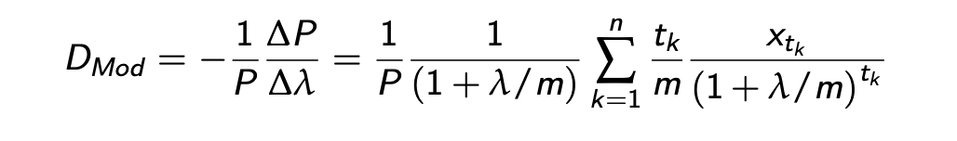
$$=\frac{1}{101.758}·\frac{1}{1+0,050637}·\left(\frac{37.411}{1+0,050637}+\frac{2·37.411}{{\left(1+0,050637\right)}^{2}}+3·\frac{37.411}{{\left(1+0,050637\right)}^{3}}\right)≈1,8723$$
5) if all spot rates move by 1 % point we adjust the discont rates and price accordingly
New spotrates
$$s_{1}=0,041667+0.01≈0,051667$$
$$s_{2}=0,048291+0.01=0,058291$$
$$s_{3}=0,055663+0.01=0,065663$$
$$d_{1}=\frac{1}{1+0,051667}≈0,95087$$
$$d_{2}=\frac{1}{{\left(1+0,058291\right)}^{2}}≈0,89287$$
$$d_{3}=\frac{1}{{\left(1+0,065663\right)}^{3}}≈0,8263$$
Now pricing
$$P=\left(0,95087+0,89287+0,8263\right)·37.411≈99,889$$
Thus if rates rise with 1% we roughly see that prices fall with $D_{mod}$

$$101.758-99,889≈1,869$$
6)
Calculating payments
We know that we must pay half the principal each time again assuming principal of 100
We must pay half plus the interest on the remaining principal
$$B_{s,1}=50+0.04·100=54$$
$$B_{s,2}=50+0.04·50=52$$
Giving cashflowvektor
$$B_{S}=\left(\begin{matrix}54 & 52 & 0\end{matrix}\right)$$
Assuming we are trading in the market from the beginning
We calculate the no arbitrage price
$$P_{s}=\left(\begin{matrix}54 & 52 & 0\end{matrix}\right)\left(\begin{matrix}0,96 \\ 0,90999 \\ 0,85001\end{matrix}\right)≈99,159<100$$
This difference seems quite large but could be because of rounding errors, ill be continuing assuming this difference is not just a rounding error
We see there must be arbitrage
We reproduce the cashflow in the market by constructing a replicating portfolio

$$\left(\begin{matrix}54 & 52 & 0\end{matrix}\right){\left(\begin{matrix}103 & 0 & 0 \\ 53.02 & 53.02 & 0 \\ 37.411 & 37.411 & 37.411\end{matrix}\right)}^{-1}≈\left(\begin{matrix}0,019417 & 0,98076 & 0\end{matrix}\right)=θ^{T}$$
This portfolio has exactly price

$$\left(\begin{matrix}0,019417 & 0,98076 & 0\end{matrix}\right)\left(\begin{aligned}98.880 \\ 99.147 \\ 101.758\end{aligned}\right)≈99,159$$
And the same cashflows thus by selling $B_{s} for 100$ and buying the replicating portfolio we gain $100-99,159≈0,841$ with no cash flows creating an arbitrage

Opg 3

$$Σ=\left(\begin{matrix}0.01 & 0.006 & 0.015 \\ 0.006 & 0.04 & 0.042 \\ 0.015 & 0.042 & 0.09\end{matrix}\right)$$
$$μ=\left(\begin{aligned}0.05 \\ 0.10 \\ 0.15\end{aligned}\right)$$
- Calculate the correlation between asset 1 and 2
$$ρ_{1,2}=\frac{σ_{12}}{σ_{1}·σ_{2}}=\frac{0.006}{0.1·0.2}≈0,3$$
Explain if you can diversify your portfolio by investing in such a portfolio
Yes some of your risk will be diversified away but not all since they move somewhat together

$$w=\left(\begin{aligned}0.3 \\ 0.5 \\ 0.2\end{aligned}\right)$$
$$σ^{2}=transpose\left(\left(\begin{aligned}0.3 \\ 0.5 \\ 0.2\end{aligned}\right)\right)\left(\begin{matrix}0.01 & 0.006 & 0.015 \\ 0.006 & 0.04 & 0.042 \\ 0.015 & 0.042 & 0.09\end{matrix}\right)\left(\begin{aligned}0.3 \\ 0.5 \\ 0.2\end{aligned}\right)=0,0265$$
$$σ=\sqrt{0,0265}≈0,16279$$
$$μ_{w}=transpose\left(\left(\begin{aligned}0.05 \\ 0.10 \\ 0.15\end{aligned}\right)\right)\left(\begin{aligned}0.3 \\ 0.5 \\ 0.2\end{aligned}\right)=0,095$$

$$r_{w}\sim N(0.095,0.0265)$$
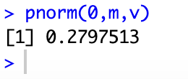
$$P\left(r_{w}≤0\right)=0.2797=28\%$$
- Variance minimizing with $μ_{P}=0.1$
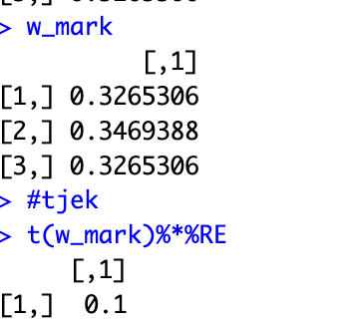
With variance
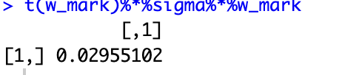
$$σ_{p}=\sqrt{0.02955102}≈0,1719$$
$$Markowitz:(0.1719,0.1)$$
- MVP
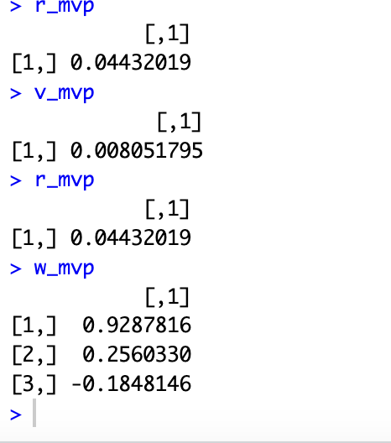
Varians så return så portføljen
$$σ_{mvp}=\sqrt{0.008051795}≈0,089732$$
$$MVP:(0.08973,0.04432)$$
- Tangensportfølje
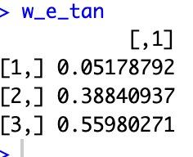
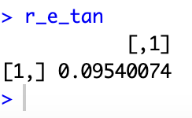
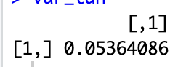
$$σ_{t}=\sqrt{0.05364}≈0,2316$$

$$r_{t}=transpose\left(\left(\begin{aligned}0.05178792 \\ 0.38840937 \\ 0.55980271\end{aligned}\right)\right)\left(\begin{aligned}0.05 \\ 0.1 \\ 0.15\end{aligned}\right)≈0,1254$$
$$Tan:(0.2316,0.1254)$$
$$s_{t}=\frac{0,1254-0.03}{0,2316}≈0,41192$$

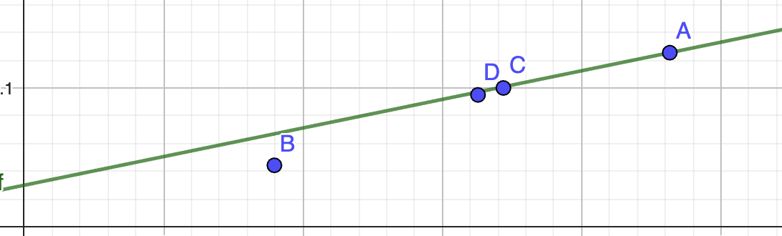
The distance form the return akse to the CML s the systematic risk i.e the risk you need to take for a wanted expected return the distance from the CML to the ortfolios is the unsystematic risk. I.e the extra risk we dident need to hold but do anyway

Opg 4
- 2
$$D=\left(\begin{matrix}2 & 0 & 2 \\ 2 & 2 & 0\end{matrix}\right)$$
$$P=\left(\begin{aligned}1 \\ 1\end{aligned}\right)$$
State prices are solutions to the equaltion
$$P=Dψ$$
- The market is arbitrage free since
$$\left(\begin{matrix}2 & 0 & 2 \\ 2 & 2 & 0\end{matrix}\right)\left(\begin{aligned}\frac{1}{4} \\ \frac{1}{4} \\ \frac{1}{4}\end{aligned}\right)=\left(\begin{matrix}1 \\ 1\end{matrix}\right)=P$$
Thus $ψ=\left(\begin{aligned}\frac{1}{4} \\ \frac{1}{4} \\ \frac{1}{4}\end{aligned}\right)>0$ is a solution and the market is arbitrage free
Since $\left(P,D\right)$ is arbitragefree it is complete $⇔ψ is unique⇒rank\left(D\right)=T=3$

$$D only has 2 rows⇒Rank\left(D\right)≤2⇒\left(P,D\right)is not complete$$
- Now we see that it is unique since D becomes invertible P is unique and the market is complete and arbitrage free since
$$D=\left(\begin{matrix}2 & 0 & 2 \\ 2 & 2 & 0 \\ 0 & 2 & 2\end{matrix}\right)$$
$$P=\left(\begin{aligned}1 \\ 1 \\ 1\end{aligned}\right)$$
$$ψ={\left(\begin{matrix}2 & 0 & 2 \\ 2 & 2 & 0 \\ 0 & 2 & 2\end{matrix}\right)}^{-1}\left(\begin{aligned}1 \\ 1 \\ 1\end{aligned}\right)=\left(\begin{matrix}0,25 \\ 0,25 \\ 0,25\end{matrix}\right)$$
- 1
We know
$$ψ_{i}=\frac{q_{i}}{1+r}$$
Since $ψ_{1}=ψ_{2}=ψ_{3}$
We must also have
$$q_{1}=q_{2}=q_{3}$$
Since probabilities
$$q_{1}+q_{2}+q_{3}=1$$
Thus
$$q_{1}=q_{2}=q_{3}=\frac{1}{3}$$

By the law of one price the price of the certain cashflow $\left(\begin{matrix}1 & 1 & 1\end{matrix}\right)$
Must be
$$ψ_{1}+ψ_{2}+ψ_{3}=\frac{3}{4}=\frac{1}{1+r}$$
$$⇒r=\frac{1}{3}$$
This of course makes sence since we kan buy 1 of each asset for the price of 3 and have a certain cashflow of 4
- We simply price the expected payout of the bought contract in terms of state prices
The forward has the payoff structure
$$f=\left(\begin{matrix}1 & -1 & 1\end{matrix}\right)$$
$$f·ψ=0.25$$

